Mr. Jones - JONESFM@scsk12.org
Ms. Rucker – RUCKERGF@scsk12.org
Website: http:// www.scsk12.org/SCS/high/Germantown/index.php
GRADING SCALE
A: 100-93
B: 92-85
C: 84-75
D: 74-70
F: 69-0
Supplies: Paper, PENCILS, graph paper, calculator, and DRY ERASE MARKER(S).

Grades will be calculated using the following weights:
Test – 40%
Quizzes – 25%
Classwork
& Participation – 25%
Homework – 10%

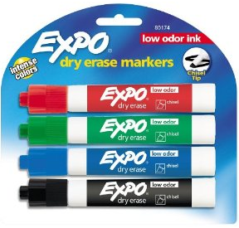
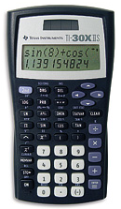

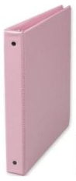
Syllabus, notes and book assignments are posted at:
Assignments for a particular section are always due the day after the section has been covered in class (the day after it appears on the syllabus). The Reference Page(s) must be kept at all times. The Reference Page(s) will be taken up and checked for completeness for a grade at least once a quarter.
Grade improvement opportunities: Students will take a nine weeks test that will count as a test grade but it can also be used to replace their lowest previous test grade. Math advisory will be held on Tuesdays for students that need reinforcement.
***MAKEUP WORK***
Makeup work is the student’s responsibility. After an excused absence, tests must be made up immediately upon return to class. However if the tests have been returned you must take the nine weeks test grade for the missed test. If you do not make up a test, the 9 weeks test grade will replace the missing test grade.
ISS: Time spent in ISS is considered as regular class time. You should take your book to ISS and review/complete the syllabus topics covered during class. Scheduled Tests will be taken in ISS. Being absent or in ISS the day before a scheduled test or quiz does not excuse the student from taking it.

Calculators will NOT be provided.

Students must bring a calculator to class every day. Students will not pass calculators back and forth during class, a test or quiz (This will result in an automatic zero for both students). Graphing calculators are required.

TN Ready STATE EXAM

Algebra II students are required to take a state mandated exam this year. Part One will be in Feb/March and Part Two will be given in April/May.

QUIZZES
Quizzes may be given at any time. They may be announced or unannounced. They may cover vocabulary, homework, bell work or items from the book.

Be prepared for a quiz at all times.

HOMEWORK
NO NAME EQUALS A ZERO!

YOU MUST SHOW ALL WORK!

Homework will be assigned four to five times a week. Every homework will not be graded, however each assignment will be reviewed in class the following day. Graded homeworks will be checked for accuracy or for completion.

Accuracy: Some assignments will be collected and checked for accuracy.

Completion: Your completed homework is due at the beginning of class. Problems must be set up and worked out neatly on your own paper.

*Use a PENCIL*
**Show All Work**
***No Late Homework Accepted***
PENCIL! PENCIL! PENCIL!
TARDIES – Be ready in your seat when the tardy bell rings. Have all materials necessary for class on your desk!

ELECTRONICS – Absolutely NO phones or headphones allowed. No iPads, iPods, kindles, nooks, cameras, computers. etc.
Stay seated until the teacher dismisses you.

Cheating is the unauthorized “getting” of answers/work from someone else or the “giving” of answer/work to someone else.

Copying someone else’s homework is CHEATING.
Shelby County Schools offers educational opportunities without regard to race, color, national origin, religion, sex, or disability.

REFERENCE SHEET

Students will be required to keep a running reference sheet of theorems, postulates and definitions.
CONSEQUENCES FOR BREAKING THE RULES:
Lowering of conduct mark
Student/parent conference
Referral to grade-level administrator

REWARDS FOR FOLLOWING THE RULES:
Conduct grade of E
Satisfaction of a job well done
Self-discipline
A safe, enjoyable classroom environment
CLASSROOM RULES:
1. Sit in your assigned seat.
2. Come to class prepared with all required supplies.
3. Be Respectful. No teasing or checking.
4. Be on task and attentive at all times.
5. Do not disrupt the learning environment of the classroom.
7. Know and follow all GHS and SCS rules and policies.

BE ON TIME! I WILL GIVE TARDIES!

